Yelp Dataset Documentation

This documentation provides a detailed explanation of the Yelp datasets, their structure, fields, relationships and some tips working with the data. Each dataset is structured as a JSONL file (JSON Lines format), with one complete JSON object per line. By using the Yelp Dataset, you expressly agree to these terms and conditions. Check the terms of use HERE.
Table of Contents
Business dataset 2
Key Fields 2
Notes on business attributes related columns 3
Tips for analysing business dataset 3
Review Dataset 3
Key Fields 3
Tips for analysing review dataset 3
User Dataset 4
Key Fields 4
Tips for analysing user dataset 4
Check-in Dataset 5
Key Fields 5
Tips for analysing check-in dataset 5
Tip Dataset 5
Key Fields 5
Tips for analysing tip dataset 5
Working with the Datasets - tips 6
Data Relationships 6
Entity Relationship Diagram 6
Ethical Considerations 7

Business dataset
The business dataset (yelp_academic_dataset_business_processed.json) is in JSONL (JSON Lines) format, where each line contains a complete JSON object representing a single business. The file contains information about businesses across multiple metropolitan areas, including location data, attributes, categories, and ratings.

Key Fields
Based on the standard Yelp Academic Dataset structure, each business entry typically includes the following fields:
Field | Type | Description
business_id | string | A unique 22-character identifier for the business
name | string | The name of the business
address | string | The street address of the business
city | string | The city where the business is located
state | string | Two-character state code (if applicable)
postal_code | string | The postal code (ZIP code in the US)
latitude | float | Geographic latitude coordinate
longitude | float | Geographic longitude coordinate
stars | float | Average rating, rounded to half-stars (from 1.0 to 5.0)
review_count | integer | Number of reviews for this business
is_open | integer | Binary indicator: 1 if the business is open, 0 if closed
Ambience | String/  boolean | They are all business attributes, which you can considered as features or services provided by the business. Most of the attributes are True/False values but some are strings or with key/value pairs.
RestaurantsGoodForGroups
RestaurantsAttire
GoodForKids
RestaurantsReservations
OutdoorSeating
BusinessParking
HasTV
Caters
RestaurantsTakeOut
BusinessAcceptsCreditCards
RestaurantsDelivery
Alcohol
RestaurantsPriceRange2
ByAppointmentOnly
WiFi
NoiseLevel
BikeParking
AmbienceList | string | This is transformed from the column “Ambience” to list the values if not null.
BusinessParkingList | string | This is transformed from the column “BusinessParking” to list the values if not null.
categories | array | Array of strings representing business categories
hours | object | Operating hours with day-of-week keys and hour range values in 24hr format

Notes on business attributes related columns
- Restaurant-specific attributes (e.g., RestaurantsTakeOut, RestaurantsDelivery, GoodForKids)
- Ambience attributes (e.g., Ambience.romantic, Ambience.casual)
- Parking options (e.g., BusinessParking.garage, BusinessParking.street)
- Price range (e.g., RestaurantsPriceRange2)
- Payment options (e.g., BusinessAcceptsCreditCards, AcceptsBitcoin)

Tips for analysing business dataset
- There are location data, which can be used to identify the distribution of restaurants in the US
- The business attributes can be useful for finding opportunities for operation
- There are categories data, which can be used to identify popular restaurant types. However, this column is with multiple categories, so you might need to split the data for analysis
- The "hours" object uses 24-hour time format which makes time-based analysis straightforward
- Consider the "is_open" field to filter out permanently closed businesses

Review Dataset
The review dataset (yelp_academic_dataset_review.json) contains full-text reviews written by users about businesses.

Key Fields
Field | Type | Description
review_id | string | A unique 22-character identifier for the review
user_id | string | The 22-character user ID who wrote the review (maps to user dataset)
business_id | string | The 22-character business ID the review is for (maps to business dataset)
stars | integer | Rating given in this review (1-5)
date | string | Date of the review in YYYY-MM-DD format
text | string | The full text of the review
useful | integer | Number of useful votes received
funny | integer | Number of funny votes received
cool | integer | Number of cool votes received

Tips for analysing review dataset
- The "text" field contains the complete review content, useful for text analysis
- Track review quality signals through the "useful", "funny", and "cool" vote counts
- This dataset is very large. Suggest you do filtering before analysis.
- Consider joining with business or user data via the respective IDs for more comprehensive analysis

User Dataset
The user dataset (yelp_academic_dataset_user.json) contains metadata about Yelp users including their friend connections and various statistics.

Key Fields
Field | Type | Description
user_id | string | A unique 22-character identifier for the user
name | string | The user's first name
review_count | integer | Number of reviews written by the user
yelping_since | string | Date the user joined Yelp (YYYY-MM-DD format)
friends | array | Array of user_ids representing friends of this user
useful | integer | Number of useful votes sent by the user
funny | integer | Number of funny votes sent by the user
cool | integer | Number of cool votes sent by the user
fans | integer | Number of fans the user has
elite | array | Array of years the user was elite (e.g., [2012, 2013])
average_stars | float | Average rating of all reviews
compliment_hot | integer | Number of hot compliments received
compliment_more | integer | Number of more compliments received
compliment_profile | integer | Number of profile compliments received
compliment_cute | integer | Number of cute compliments received
compliment_list | integer | Number of list compliments received
compliment_note | integer | Number of note compliments received
compliment_plain | integer | Number of plain compliments received
compliment_cool | integer | Number of cool compliments received
compliment_funny | integer | Number of funny compliments received
compliment_writer | integer | Number of writer compliments received
compliment_photos | integer | Number of photo compliments received

Tips for analysing user dataset
- Think about why you need to analyse data before analysing this dataset
- This data can be linked to review data. They are all users who used to write reviews in Yelp.

Check-in Dataset
The checkin dataset (yelp_academic_dataset_checkin.json) contains records of when users checked in to businesses.

Key Fields
Field | Type | Description
business_id | string | The 22-character business ID (maps to business dataset)
date | string | Comma-separated list of timestamps for each checkin (YYYY-MM-DD HH:MM:SS format)

Tips for analysing check-in dataset
The check-in data is stored as a single comma-separated string, so you'll likely need to parse it for analysis:
- Split the date string by commas to get individual timestamps
- Convert each timestamp to a datetime object
- You will get one timestamp in one line, which means if one business has multiple check-in there will be multiple records for one business

Tip Dataset
The tip dataset (yelp_academic_dataset_tip.json) contains short suggestions written by users about businesses. Tips are shorter than reviews and tend to convey quick suggestions.

Key Fields
Field | Type | Description
text | string | The text content of the tip
date | string | When the tip was written (YYYY-MM-DD format)
compliment_count | integer | Number of compliments the tip received
business_id | string | The 22-character business ID (maps to business dataset)
user_id | string | The 22-character user ID who wrote the tip (maps to user dataset)

Tips for analysing tip dataset
- Tips are shorter than reviews and often contain quick suggestions or highlights
- The "compliment_count" field can help identify valuable or popular tips
- Join with business data to gain context about which business it's for

Working with the Datasets - tips
Read the data directly from GCS in Google Colab using Python – check this demo code
These datasets can be quite large. Consider these approaches for handling them:
- Chunking: Read the file in manageable chunks
- Database Import: Load into a data warehouse (i.e., GBQ) for efficient querying
- Filtering: Extract only the fields or records you need during initial processing

Data Relationships
The datasets are interrelated through shared IDs:
- business_id links businesses to their reviews, tips, and check-ins
- user_id links users to their reviews, tips, and to other users (via friends)
- review_id uniquely identifies each review
This relational structure allows for complex analyses across multiple datasets.

Entity Relationship Diagram
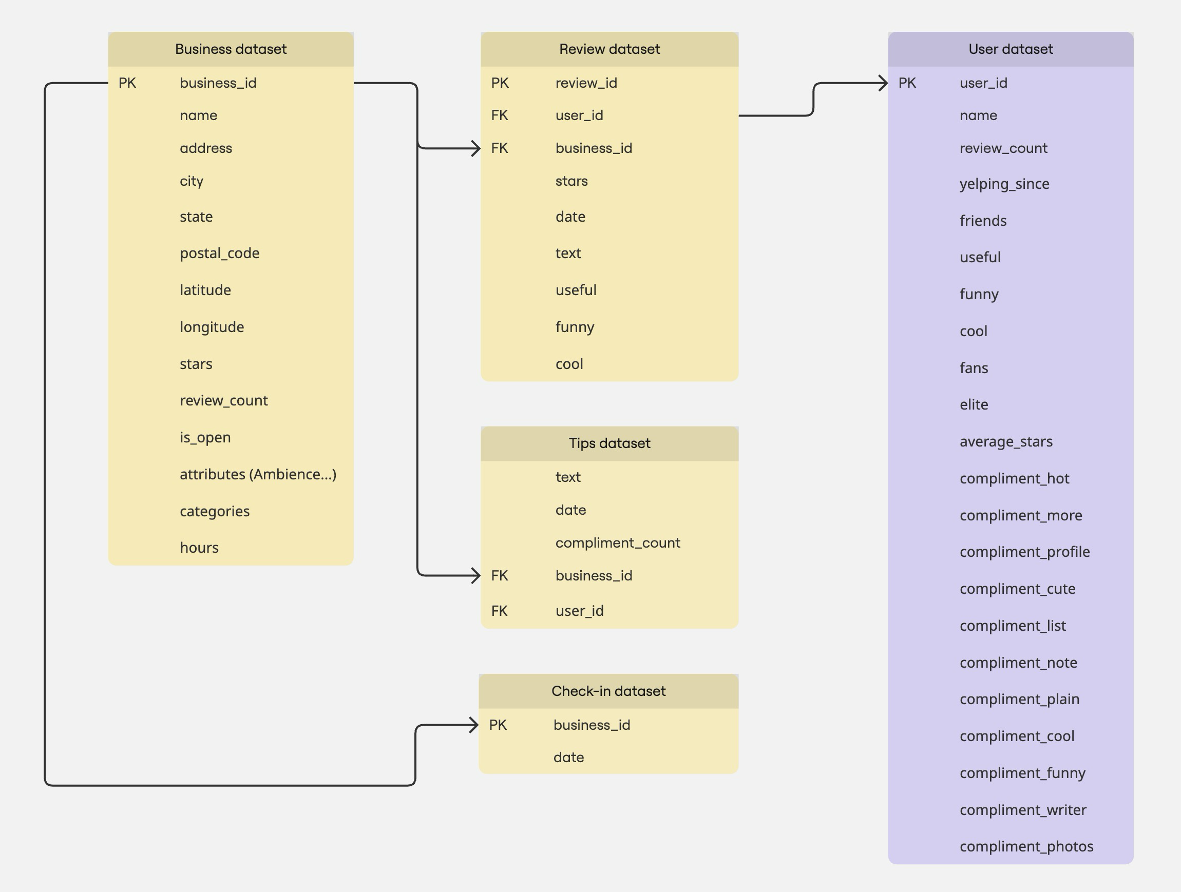

Ethical Considerations
When working with this dataset, consider ethical implications:
- Respect user privacy even though the data is anonymized
- Be cautious about drawing conclusions about individuals or specific businesses
- Consider potential biases in the dataset (selection bias, reporting bias, etc.)
- Follow the Yelp Dataset Terms of Use which restrict commercial usage
Remember that this dataset is provided for academic purposes only, and Yelp maintains specific terms of use that prohibit commercial applications or public redistribution of the data.

